

Session: 2021 – 2025

**Submitted by:**

Abdul Mateen 2021-CS-190

**Supervised to:**

Dr. Maida Shahid

Department of Computer Science

**University of Engineering and Technology**

**Lahore Pakistan**

**Limitations :**

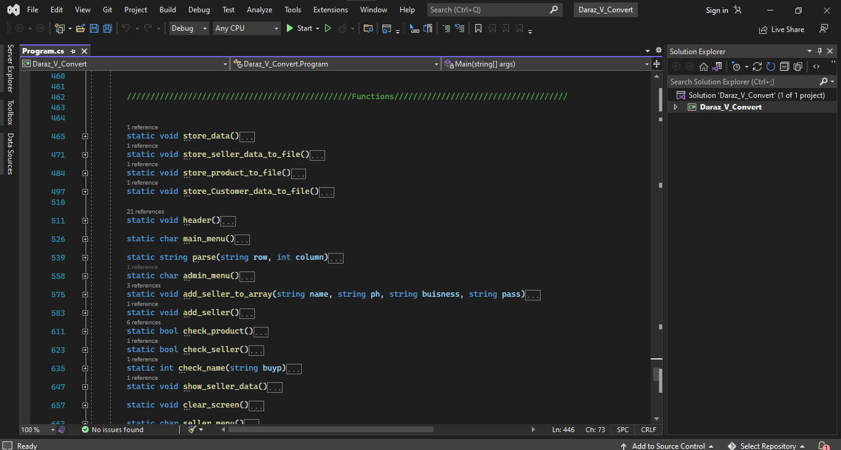

The functions are highly decoupled and dependent on each other.

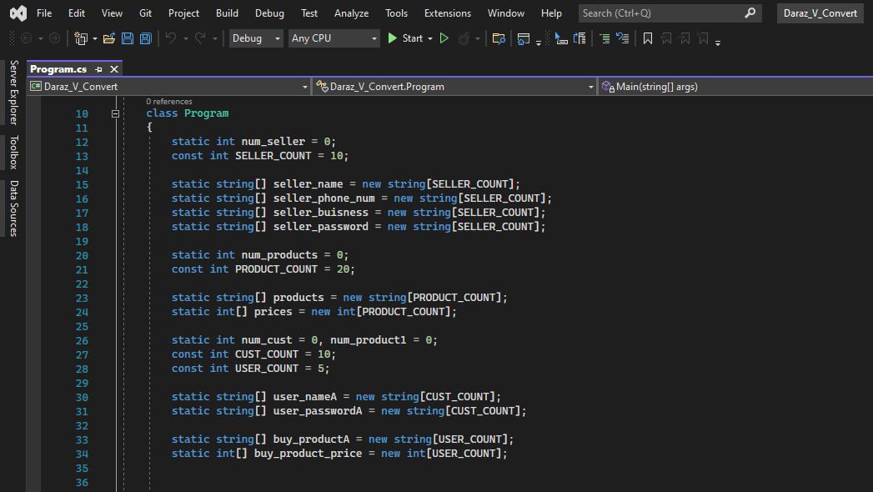

We have to initialize the array globally. We have to predefine the size of array.

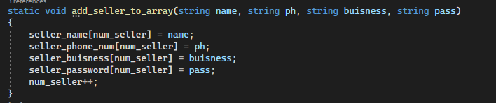

We have to pass the parameters to every functions in most of the cases. Also we cannot pass a specific part of array to a function we have to pass the whole array.

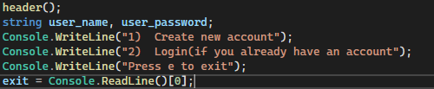

Some of code is repeating again and again. For example the code to create account and to change is repeating again and again.

These are some of the major problems of Procedural Programming.